AcademyGetting started
Chapter list
Contains 2 chapter

Temu Advertising Best Practices
Overview
Set up your Temu Ads management in 3 simple steps：
1. Local seller’s Seller Account login https://ads.temu.com or the Seller Account's menu bar "Product Ads" to access the advertising system，Sign the agreement with your main account；
2. Set up advertising service payment reserve via ‘Billing’；
3. Select the items you want to promote In 'Product Advertising', set your ROAS and budget, then launch your campaign.
Step-by-Step Visual Instructions + Troubleshooting
1. Login： a. local seller sub-account Authorization problem：how to grant advertising permissions to sub-accounts
Sample screenshots：
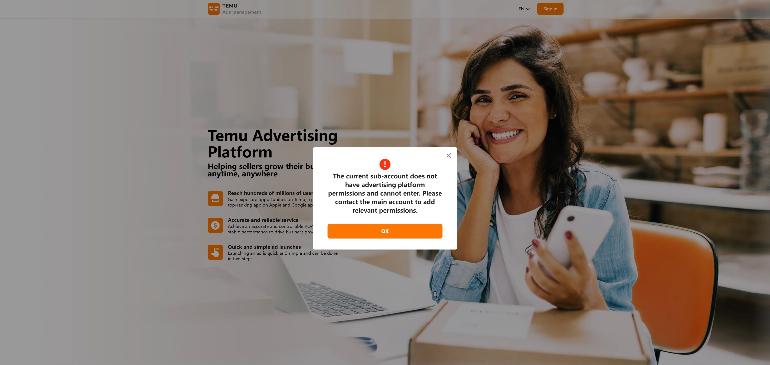
Solution：Login with the main account，find the 'My account's User perimissions, Authorize the sub-account for 'Advertising's 'Advertising Settings' and 'Charge Management'
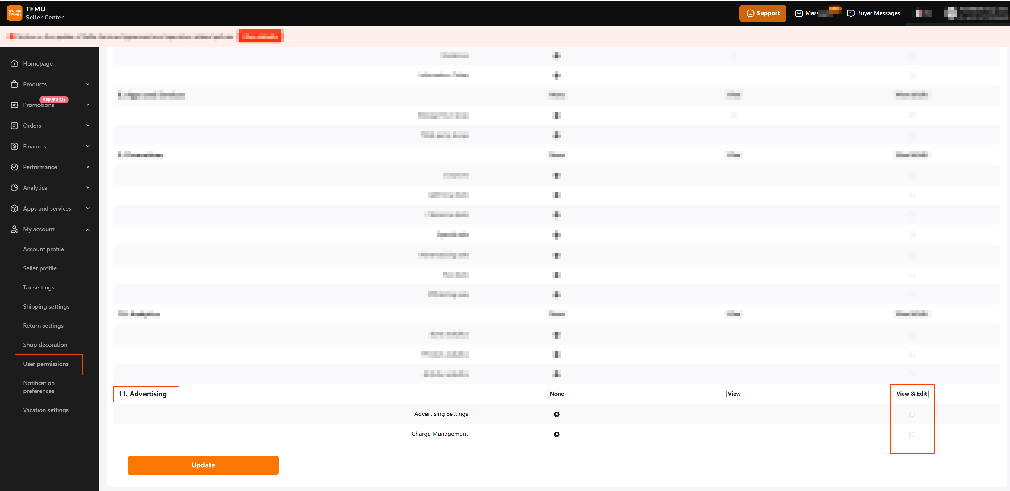
b.Login https://ads.temu.com or the Seller Account's menu bar "Product Ads" to access the advertising system
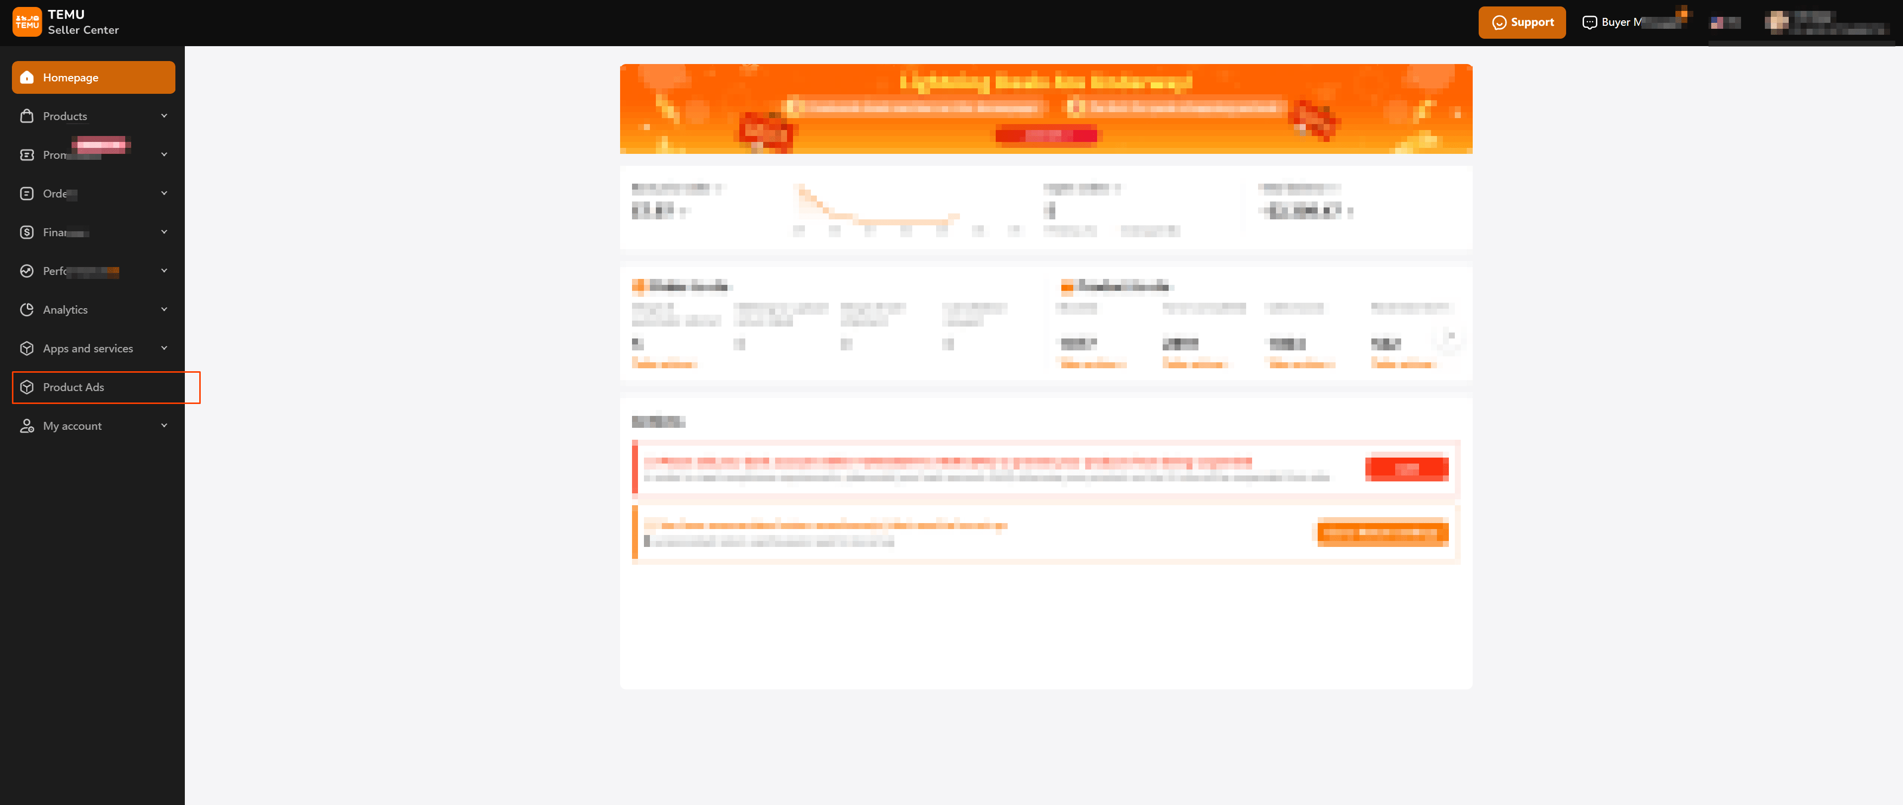
2.Sign agreement：Sign the agreement with your main account

3.Set up advertising service payment reserve
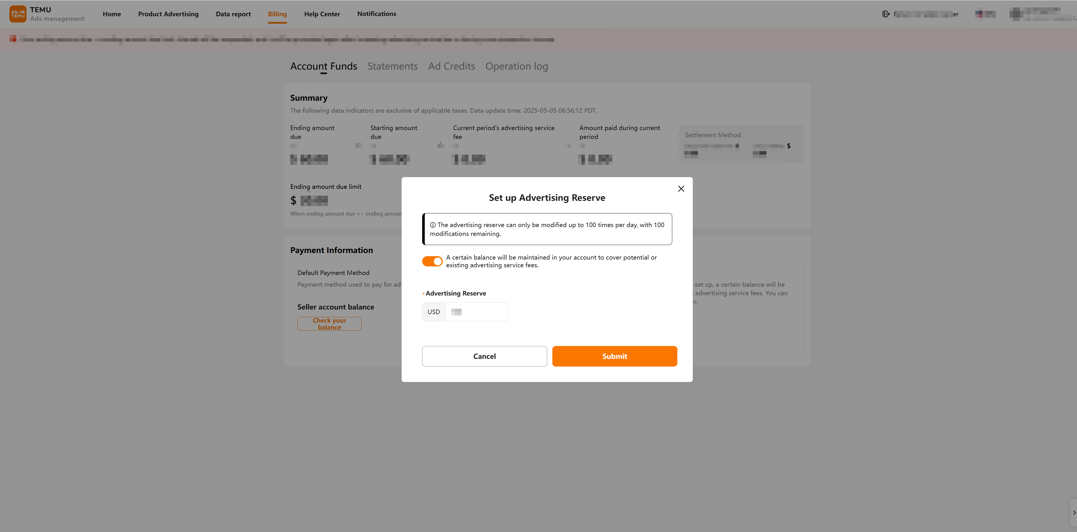
4. Create Ads： a. Create Ads：
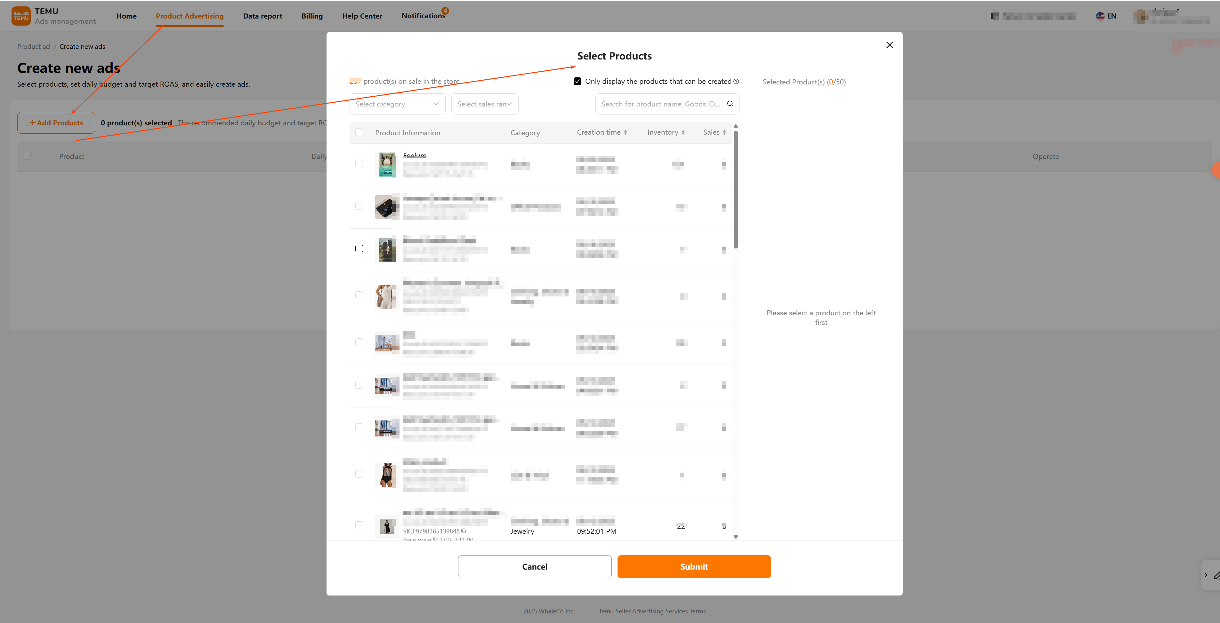
b.If the target item can't be found, perhaps the item has already been created or rejected. Remove the filter 'Only display the products that can be created’.
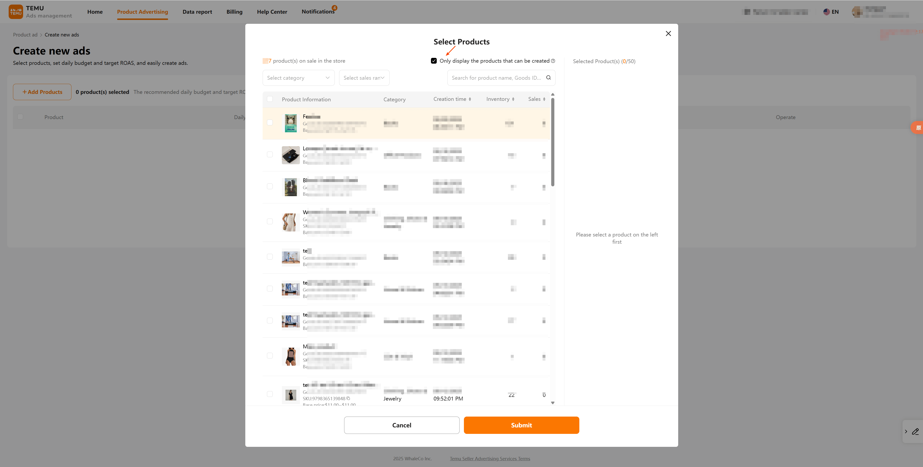
c. Review failed： i. Review rejection reasons via the help icon (?) and perform necessary revisions.
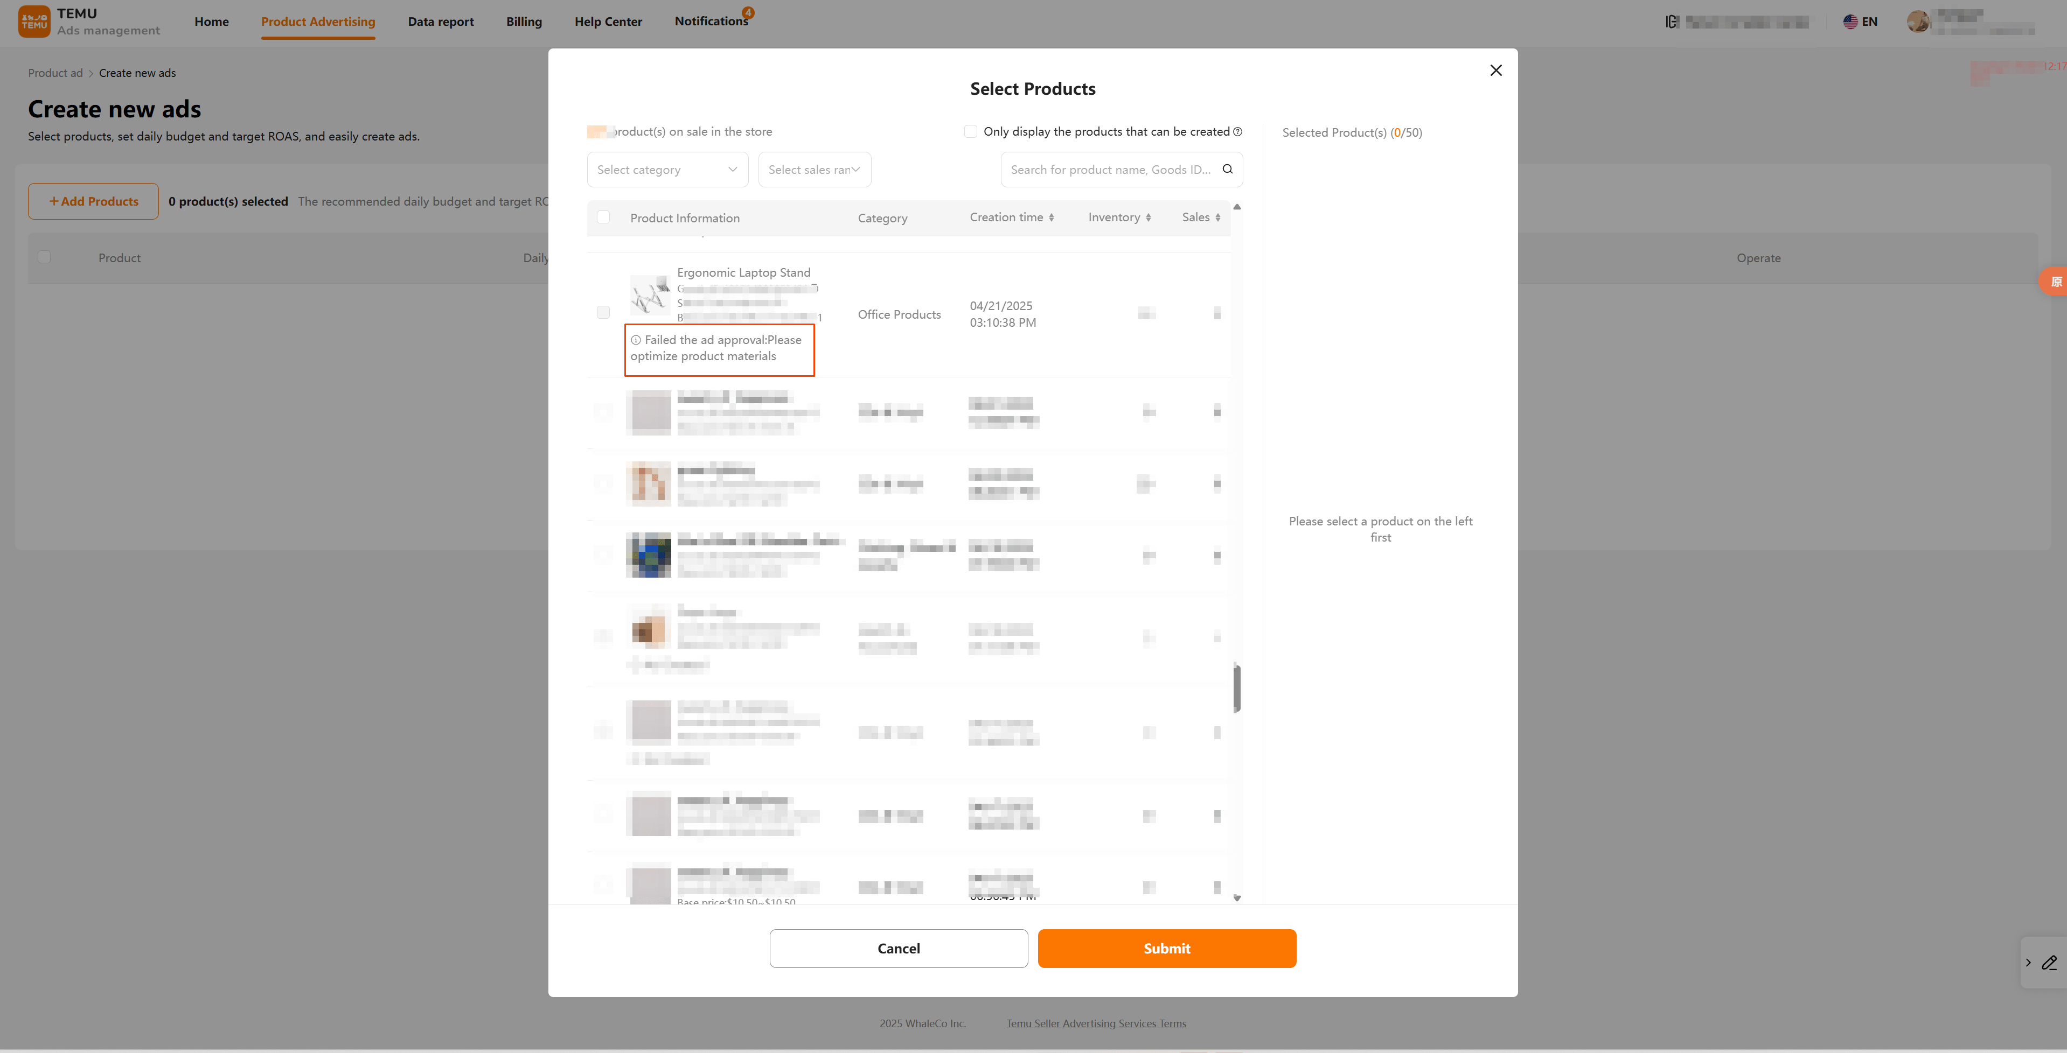
【The above content is for reference only】
© 2026 WhaleCo Inc.
Policies

